**Wonderland** **Oversea Education Service Webpage**

**1. Business and Market Requirements**

***1.1 Business Requirements***

Center for China & Globalization (2022) shows that from 2013 to 2019, the number of Chinese students studying abroad grew year by year, with fluctuating growth rates. By 2019, the size of China's study abroad population has exceeded 700,000. Although the number of students studying abroad in 2020-2021 has decreased due to the impression of COVID-19 pandemic, the market for study abroad continues to expand. However, the information of overseas study is deficient, and there is no platform for sharing certain experience. Thus, it is always struggleful for students to apply for graduate schools. And they usually resort to third-party consulting institutions, which cost lots of money. This project implements an online webpage where students and tutors can communicate and trade. The webpage will reduce the students’ application cost and provide a part-time job opportunity for tutors.

Using the **SMART** goals is an effective method to analyze the process of business objective. The acronym of SMART stand for specific, measurable, achievable, relevant and time-bound.

* *Specific*: The webpage's end users are students and tutors. Students can upload their requirements, such as resume (CV) amendments and writing, on the webpage. Tutors can be anyone with experience and qualifications like seniors who have applied to a prestigious university or graduated and run their own personal pages for students to choose from. When a tutor receives an order from a student, an order is generated.
* *Measurable*: In order to complete the study abroad support webpage, we have conducted a preliminary analysis of the current study abroad market (see the detailed analysis below in marketing requirement) and believe it has the potential to grow.
* *Achievable*: To achieve the e-commerce website, our group member with different major like computer science, information system and information management and digital media technology have comprehensive thinking from multiple perspective. The web page was created by using PHP.
* *Relevant*: The whole process was relevant with each step.
* *Time-based*: To achieve the business goals. Our group decided to do a study abroad application support webpage after brainstorming on March 26th. then we worked together to complete the project requirement document before April 7th. The prototype of the e-commerce website is expected to be ready by April 15.

As a me2 business, there are similar industries such as offline study abroad agents and online platforms like Taobao and Xianyu where you can search for this service, but the quality of the service is not guaranteed. Our webpage is a way of concretizing and refining this service, providing a higher quality match through back-end data.

***1.2 Market Requirements***

***1.2.1 The size and potential of the self-funded study services market***

Increasingly fierce competition in the college entrance exam has raised the threshold of the employment market, more and more working-class and middle-class parents are turning their eyes to foreign universities. According to official data from China's Ministry of Education, the number of Chinese students studying abroad has continued to climb, reaching 662,000 in 2018, with a self-funding rate of 90%. The 2017 global survey "The Value of Education: Reaching for the Top" of Hongkong and Shanghai Banking Corporation reports that 41% of parents are considering sending their children to study abroad despite the high cost of doing so, and over 80% of Chinese parents say they are willing to fund their children's studies and support them in obtaining higher degrees. Even more than 72% of Chinese parents are concerned that they are not doing the best for their children, higher than the global average (59%). The increase in demand for study abroad has led to a rapid increase in the number of agents providing study abroad services.

According to the Ministry of Education, the vast majority of international students who go through the process of studying abroad end up choosing a study abroad agent to do so, with the cost of study abroad agent services accounting for 2% of the study abroad industry's market share. There are usually 3 ways to study abroad at your own expense, namely applying to go abroad through a study abroad agent, preparing your own documents to apply to a school, and going through a school exchange program, of which about 70% of students use an agent to achieve their application to a school abroad.

The current market size of study abroad intermediaries in China is less than 10 billion yuan, with an average annualized growth rate of 6% from 2015-2019. in 2020, the new crown pneumonia hits the world; study abroad intermediary services in China are hit harder compared to study abroad training services, so the market size of study abroad intermediaries in China is about 4.5 billion yuan in 2020, down about 30% from 2019.

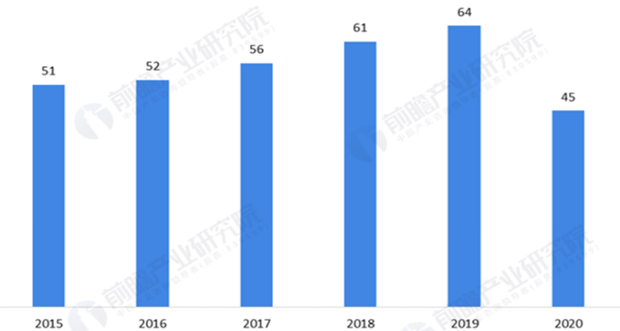

Figure 1: Market size of Overseas study agency in China from 2015 to 2020 (unit: 100 million Yuan)

China Study Abroad Service Industry Market Outlook and Future Investment Strategy Analysis Report 2021-2026 published by China Research Institute of Industry predicts that China's study abroad service industry will be in a period of moderate development from 2021-2023, but will start to grow at a high rate since 2024 and the market size will exceed that of 2019 to reach 467.9 billion yuan in 2024, and then rise at a growth rate of about 13%, and the market size of China's study abroad service industry will be close to 600 billion yuan in 2026. The market size of China's study abroad service industry will be close to RMB 600 billion in 2026.

***1.2.2 The problems in the self-financed overseas study service market***

The 21st century is the era of the Internet, and "Internet+" is the trend of the times, and all social industries are becoming increasingly digital, intelligent, and systematic, and the study abroad industry is no exception. Nowadays, homogeneous competition in the study abroad service industry has intensified and study abroad service providers are blooming everywhere. However, there are some problems in the development of the self-financed study abroad industry.

*(1) Serious phenomenon of relying on and selling qualifications in disguise*

At the beginning of the approval of the qualification of intermediary services, there were many domestic institutions engaged in study abroad consultation, but only a portion of them met the criteria to obtain the qualification to carry out study abroad consultation, and even fewer of them met the criteria to handle only single-country study abroad business, so many institutions managed to rely on the qualified institutions to act as a project department for country study abroad. As a result, there are unclear contract subjects, uneven distribution of benefits and serious irregularities, which seriously affect the credibility of the study abroad intermediary industry; with the development of the internet, some unqualified agencies carry out study abroad consultation and visa counselling through the advantage of the internet; they carry out study abroad intermediary business under the name of other agencies, etc.

*(2) Serious irregularities in the operation of qualified intermediaries*

Previously, the serious falsification of Chinese students' documents by institutions in the United States and the United Kingdom reflected that domestic intermediaries were willing to falsify their application documents, especially their academic qualifications, in order to seek profits in the process of application. In the process of applying to institutions, the practitioners of some institutions do not design plans for students according to the principle of "people-oriented and tailor-made", but recommend institutions with high rebates for students to choose from, which leads to some students not being able to apply to suitable institutions and the interests of consumers being damaged. In terms of signing agreements with clients for intermediary services, only a few dozen of them currently use the "Contract for Commissioning Services for Self-financed Study Abroad Intermediary Services (Model Text)" promoted by the Ministry of Education, which still puts the interests of the institution first in issues such as fees and refunds, and does not reflect the balanced interests of consumers and service providers.

*(3) Lack of a platform for peer-to-peer exchanges with overseas educational institutions or bodies*

The lack of reciprocal communication, consultation and negotiation in international education matters and negotiations has left agencies in a passive and helpless position in the event of problems with students abroad.

***1.2.3 Target market and user orientation***

This product provides a trading platform for study abroad services and adopts a C2C business model. Users can freely publish and sell overseas study application consultation, CV or personal statement (PS) writing and other services, or purchase overseas study service products on the platform.

The current study abroad market is booming and the number of people interested in studying abroad has increased dramatically, but the application planning and process needs professional guidance so agencies have emerged. Agencies work in a streamlined manner and do not have a thorough understanding of the school or the student, so students often do not get a satisfactory outcome. In addition, there is currently no product on the market that effectively solves this problem, and this product will provide a bridge between the target group who are applying or intends to study abroad and those who have experience in applying and are interested in selling their study abroad services. Those who are applying or interested in studying abroad can use the platform to filter the services that meet their requirements and purchase them selectively with intelligently and efficiently.

**2. Functional and UI/UX Requirements**

***2.1 Functional Requirements***

For this webpage, we divide our users into 4 categories, say, Admin, User, Seller, and Buyer. In this section, we will use User Case to elaborate the functional requirements.

***2.1.1 Purchase services***

|  |  |
| --- | --- |
| Use Case ID: | 1 |
| Use Case Name: | Purchase services |
| Actors: | Buyer |
| Description: | A Buyer accesses the webpage, and optionally views the service items from a specify store or the information square, and purchase a service and complete payment. |
| Preconditions: | 1. Buyer is registered and logged into webpage. |
| Postconditions: | 1. Webpage receives payment from Buyer.  2. The shop has confirmed receipt of the order.  3. Service order is stored in webpage system and wait for completing. |
| Normal Flow: | **1.0 Purchase a service**  1. Buyer asks to view list of service items for a specified service.  2. Webpage displays list of available service items and relevant details (such as price, score, and shop).  3. Buyer selects one service item, and add it into shopping cart.  4. Webpage displays the product is added successfully.  5. Buyer asks to view shopping cart.  6. Shopping cart of Webpage displays added service items, individual prices, and total price, including any taxes and delivery charge.  7. Buyer confirms services order or requests to modify services order (back to step 3).  8. Buyer decides to settle and specifies payment method.  9. Webpage confirms acceptance of the order, and notifies shop to complete order.  10. Webpage stores order in database, and transfers money to shop after the order be completed. |
| Alternative Flows: | **1.1 Purchase service from specified shop** (branch at step 1)  1. Buyer views service items from a specified shop.  2. Return to step 3.  **1.2 Purchase service from information square** (branch at step 1)  1. Buyer views messages from information square.  2. Buyer views service in a specified message.  3. Return to step 3.  **1.3 Purchase multiple services** (branch after step 4)  1. Buyer selects another service, and add it into shopping cart.  2. Return to step 4.  **1.4 Delete products from shopping cart** (branch after step 6)  1. Buyer selects specified products and delete.  2. Return to step 6.  **1.5 Purchase services by filtering** (branch at step 1)  1. Buyer enter the key words of the services they want.  2. The webpage display the searching results.  3. Return to step 3.  **1.6 Purchase services from category** (branch at step 1)  1. Buyer choose a specific category page for browsing.  2. Return to step 3.  **1.7 Claim for** **refund** (branch after step 8)  1. Buyer finds the item to be refunded in the history, and claims for refund.  2. Upon receipt of the request, Webpage initiates a refund and may compensate the store by deducting a certain amount of penalty according to the rules of Webpage.  3. Return to step 1.  **1.8 Claim for** **invoice** (branch after step 8)  1. Buyer selects specified products to claim for invoice.  2. Shop provides invoices to Buyer.  3. Return to step 1. |
| Exceptions: | **1.0.E.1 Products in shopping cart are off-shelve** (at step 7)  1. Webpage informs Buyer products are not available, and asks if delete products from shopping cart.  2a. Buyer deletes unavailable products.  2b. Webpage updates shopping cart.  **1.5.E.1 Product is not refundable** (at step 2)  1. Webpage informs Buyer the product is not refundable for specific reasons, and provides manual services entrance. |
| Includes: | None |
| Priority: | High |
| Frequency of Use: | Approximately 500 users, average of one usage per day |
| Special Requirements: | 1. Buyer shall be able to cancel the service order at any time prior to confirming the order.  2. Buyer shall be able to view all services he ordered within the previous six months and repeat one of those services as the new order, provided that the service and shop are available. (Priority = medium) |
| Assumptions: | None |
| Notes and Issues: | 1. Expect high frequency of executing this use case within half year before the university application deadline. |

***2.1.2 Post and delete message***

|  |  |
| --- | --- |
| Use Case ID: | 2 |
| Use Case Name: | Post and delete message |
| Actors: | User, Admin |
| Description: | A User accesses the webpage, and optionally post or delete personal messages in information square. |
| Preconditions: | 1. User is registered and logged into webpage.  2. The message to be deleted should match the identity of the actor. |
| Postconditions: | 1. Actions of User are recorded by webpage and updated to all users. |
| Normal Flow: | **2.0 Post and delete message**  1. User enters the information square.  2. User asks for post message in information square.  3. Webpage displays a text box for User to input message (including Includes title, body, picture, and video).  4. User finishes editing the message, and posts it to information square.  5. Webpage informs User message is posted successfully, and updates information square to all users.  6. User finds the message he/she post previously in information square, and selects deletion.  7. Webpage asks if confirms deletion.  8. User confirms deletion.  9. Webpage informs User message is deleted successfully, and updates information square to all users. |
| Alternative Flows: | **2.1 Delete messages in User’s own message list** (branch at step 6)  1. User finds the message he/she post previously in the message list of User, and selects deletion.  2. Return to step 7.  **2.2 Cancel deletion** (branch after step 7)  1. User cancels deletion.  2. Return to step 6.  **2.3 Delete message by admin** (branch at step 6)  1. The admin specifies the message to be deleted.  2. Return to step 7.  **2.4 Delete multiple messages** (branch at step 6)  1. Users selected multiple messages they post in the discussion area before.  2. Return to step 7. |
| Exceptions: | **2.0.E.1 Message posted failure** (at step 5)  1. Webpage informs User that fail to post message for specific reasons (such as exists prohibited words, mis-formed or unrecognizable characters, and fail to upload picture or video).  2a. User modifies the content, and re-post message.  2b. Webpage informs User message is posted successfully or failure (back to step 1).  3a. User cancel post message.  3b. Webpage ask if store content to draft box. If yes, stores content to draft box; otherwise, deletes content.  **2.1.E.1 Message has been deleted** (at step 1)  1. Webpage informs User that message has been deleted for specific reasons (such as be reported). |
| Includes: | None |
| Priority: | High |
| Frequency of Use: | Approximately 2 times per week by one user |
| Special Requirements: | 1. User shall be able to cancel post the message at any time prior to confirming post the message.  2. User shall be able to view all messages he/she posted in User’s own message list.  3. User shall be able to find un-post messages in draft box. (Priority = medium) |
| Assumptions: | 1. Assume that the image and video uploaded by User cannot exceed 500 MB (source: survey of similar software). |
| Notes and Issues: | 1. Webpage shall indicate which characters or contents may cause post failure. Webpage shall not permit a User to post messages includes these contents. |

***2.1.3 Chat and manage chat***

|  |  |
| --- | --- |
| Use Case ID: | 3 |
| Use Case Name: | Chat and manage chat |
| Actors: | User (Buyer and Seller) |
| Description: | A User accesses the webpage, as a buyer, he/she could optionally selects shop to chat, and performs chats management including delete, browse, flag, and report. For sellers, they could response messages from buyers. |
| Preconditions: | 1. User is registered and logged into webpage.  2. User must have a chat record if he/she wants to manage a chat. |
| Postconditions: | 1. All actions of User are recorded by webpage. |
| Normal Flow: | **3.0 Chat and manage chat**  1. User (Buyer) selects and enters a shop by specified method (such as directly search, find in information square, find in followed shops).  2. User asks to initiate chat, and starts to chat.  3. User ends chat.  4. User asks to displays chat list.  5. Webpage displays chat list.  6. User selects specified chat, and deletes it.  7. Webpage records actions of User. |
| Alternative Flows: | **3.1 Response the user** (branch at step 1)  1. The seller responses the message initiated from the buyer.  2. Return to step 3.  **3.2 Accept chats** (branch at step 1)  1. User accept chats from other user or shop, and starts to chat.  2. Return to step 3.  **3.3 Browse/flag/report chat** (branch after step 5)  1. User browses/flags/reports specified chat.  2. Return to step 7. |
| Exceptions: | **3.0.E.1 Initiate chat failure** (at step 2)  1. Webpage informs User that fail to initiate chat for specific reasons (such as this shop or user has been deregistered, or this user has blocked User). |
| Includes: | None |
| Priority: | High |
| Frequency of Use: | Approximately 30 times per week by one user |
| Special Requirements: | 1. User shall be able to view all chat records in User’s chat list. |
| Assumptions: | 1. Assume that the individual chat content sent by User cannot exceed 500 MB (source: survey of similar software). |
| Notes and Issues: | None |

***2.1.4 Feedback or rating***

|  |  |
| --- | --- |
| Use Case ID: | 4 |
| Use Case Name: | Feedback or rating |
| Actors: | User |
| Description: | A User accesses the webpage, and provides feedback (or rate) to shops or webpage administrators about purchased services and user experience. |
| Preconditions: | 1. User is registered and logged into webpage.  2. User must have purchased services if he/she wants to rate purchased products. |
| Postconditions: | 1. Feedback about the user experience reported to webpage administrators is recorded and carefully considered.  2. Report about shop or product reported to webpage administrators is recorded, and wait for processing.  3. Rating about purchased services reported to shop is recorded, and be counted as a score of shop and service, and display to all users. |
| Normal Flow: | **4.0 Feedback or rating**  1. User selects specified purchased service from history, and asks to rating.  2. Webpage displays a text box for User to input detail.  3. User finishes editing detail, and clicks on submit.  4. Webpage informs User feedback is submitted successfully, and wait for processing. |
| Alternative Flows: | **4.1 Feedback user experience** (branch at step 1)  1. User enters to the user feedback page, and asks to feedback to webpage administrators.  2. Return to step 2.  **4.2 Feedback shop or service** (branch at step 1)  1. User selects specified purchased service or shop, and asks to feedback to webpage administrators.  2. Return to step 2. |
| Exceptions: | **4.0.E.1 Feedback submitted failure** (at step 4)  1. Webpage informs User that fail to submit feedback for specific reasons (such as exists prohibited words, mis-formed or unrecognizable characters, and fail to upload picture or video).  2a. User modifies the content, and re-submit feedback.  2b. Webpage informs User feedback is submitted successfully or failure (back to step 1).  3. User cancel submit feedback. |
| Includes: | None |
| Priority: | Medium |
| Frequency of Use: | Approximately 30 times per week by one user |
| Special Requirements: | 1. User shall be able to cancel submit the feedback at any time prior to confirming submit the feedback. |
| Assumptions: | 1. Assume that the image and video uploaded by User cannot exceed 500 MB (source: survey of similar software). |
| Notes and Issues: | 1. Webpage shall indicate which characters or contents may cause submit failure. Webpage shall not permit a User to submit feedback includes these contents. |

***2.1.5 Basic functions***

|  |  |
| --- | --- |
| Use Case ID: | 5 |
| Use Case Name: | Basic functions (Log in/Log out/change password) |
| Actors: | User, Admin |
| Description: | The user or admin could log in/out the system and could change his/her password. |
| Preconditions: | **For ‘Log in’:**  1. The username is valid and has been stored in the database.  2. User is not logged into the system.  **For ‘Log out’:**  1. User is logged into the system.  **For ‘change password’:**  1. The username is valid and has been stored in the database.  2. The corresponding password has been verified.  3. The new password should be different from the previous one.  4. The user should be logged into the system. |
| Postconditions: | The user has logged in/out the system; the user has changed his/her password. |
| Normal Flow: | **5.0 Basic functions**  **5.0.1 For ‘Log in’:**  1.The user should enter his/her username and password in the required text field.  2.If the username and password are correct, the webpage will display a prompt box notifying the successful login.  3. The webpage will then redirect to the user’s home page.  **5.0.2 For ‘Log out’:**  1.The user should click the button ‘Log out’.  2.Then the webpage will display a dialog box to double check.  3.If the user hope to log out, he/she should confirm it.  **5.0.3 For ‘change password’:**  1. The webpage requires the user to enter the current password.  2.The user enter the current password.  3. The webpage checks the password and then asks the user to enter a different new one.  4. The user enters the new password.  5. The user submits his/her request and the webpage will display a prompt box notifying the successful modification. |
| Alternative Flows: | **5.1 Cancel logging out** (branch at step 5.0.2.3)  1. The user hope not to log out, he/she could cancel the process.  2. The webpage will redirect to the last page.  **5.2 Cancel changing password** (branch at step 5.0.3)  1. The user terminates the process of changing password and the webpage will redirect to the last page. |
| Exceptions: | **5.0.E.1 Invalid username or password** (at step 5.0.1.2 or 5.0.3.3)  1. Webpage informs the user there is an invalid username or password, and let he/she check it and try again.  2. Return to the step 5.0.1.1 or 5.0.3.1.  **5.0.E.2 Invalid new password** (at step 5.0.3.5)  1. Webpage informs the user there is an invalid new password, and let he/she check it and try again. |
| Includes: | None |
| Priority: | High |
| Frequency of Use: | Approximately 2 times per week by one user |
| Special Requirements: | None |
| Assumptions: | None |
| Notes and Issues: | 1. Webpage shall indicate which characters or contents may cause the failure of logging in/out and changing password. |

***2.1.6 Credential verification and management***

|  |  |
| --- | --- |
| Use Case ID: | 6 |
| Use Case Name: | Credential verification and management |
| Actors: | Admin |
| Description: | The admin could verify the credential of sellers to make them eligible for providing services. |
| Preconditions: | 1. User is registered and logged into webpage. 2. The user’s identity should be ‘Admin’. |
| Postconditions: | The credential of the seller has been verified and a notification will be sent to the seller. |
| Normal Flow: | **6.0 Credential verification and management**  1. The admin should check the required field filled by the seller one by one.  2. If the seller is eligible for providing service, the admin will permit his/her request and a notification will be updated to the seller.  3. The permitted records will be stored in the database and could be viewed from the history page. |
| Alternative Flows: | **6.1 Deny request** (branch at step 2)  1. The admin deny his/her request.  2. The webpage will ask the admin fill the textbox with the reason for rejection.  3. The admin fills the textbox and submits his/her decision.  4. A notification will be sent to the seller.  **6.2 View history records** (branch after step 3)  1. The admin views the records in the history page.  2. The admin chooses the specific one and views its details.  3. After viewing the chosen one, the admin could return to the step 6.2.1. |
| Exceptions: | **6.1.E.1 Invalid new password** (at step 6.1.3)  1. The reason of rejection is invalid, and the webpage will ask the admin to consider his/her language and enter the reason again. |
| Includes: | None |
| Priority: | High |
| Frequency of Use: | Approximately 20 users, average of one usage per day |
| Special Requirements: | None |
| Assumptions: | None |
| Notes and Issues: | None |

***2.1.7 Service management***

|  |  |
| --- | --- |
| Use Case ID: | 7 |
| Use Case Name: | Service management – Post service and Delete service |
| Actors: | Seller |
| Description: | Seller post services such as CV/PS modification and consultation in their store for other users to view and buy. Seller could delete the service they posted, and the service will be eliminated from the store. |
| Preconditions: | 1. User is registered and logged into webpage. 2. The user has been verified as a ‘seller’. 3. The service to be deleted should be posted by the actor. |
| Postconditions: | The service has been posted in the seller’s store and the information has been recorded into the database. The service has been deleted from the store. |
| Normal Flow: | **7.0 Service management**  **1. For Post service**  1. The webpage displays a form for sellers to fill in.  2. The seller specifies the description and basic attributes of the service, such as type, price, etc.  3. The seller submit the post and confirm his/her decision.  4. The service will be added into the user’s store.  **2. For Delete service**  1. The seller browses services he/she posted before and chooses a specific one to delete.  2. The webpage asks the seller to confirm his/her decision.  3. The service has been deleted and eliminated from the store. |
| Alternative Flows: | None |
| Exceptions: | **7.0.E.1 Service posted failure** (at step 7.0.1.3)  1. Webpage informs User that fail to post service for specific reasons (such as exists prohibited words, mis-formed or unrecognizable characters, and fail to upload picture or video).  2a. User modifies the content, and re-post service.  2b. Webpage informs the seller whether the service is posted successfully or unsuccessfully (back to step 1).  3a. Seller cancel post service.  3b. Webpage ask if store content to draft box. If yes, stores content to draft box; otherwise, deletes content. |
| Includes: | None |
| Priority: | High |
| Frequency of Use: | Approximately 100 users, average of one usage per day |
| Special Requirements: | 1. Seller shall be able to cancel post the service at any time prior to confirming post the service.  2. Seller shall be able to view all services he/she posted in his/her store.  3. Seller shall be able to find un-post services in draft box. (Priority = medium)  4. Seller shall be able to cancel delete the service at any time prior to confirming delete the service. |
| Assumptions: | 1. Assume that the image and video uploaded by User cannot exceed 500 MB (source: survey of similar software). |
| Notes and Issues: | None |

***2.1.8 Order Management***

|  |  |
| --- | --- |
| Use Case ID: | 8 |
| Use Case Name: | Order Management |
| Actors: | Seller |
| Description: | The seller manages the order initialized by the buyer and starts providing corresponding service. |
| Preconditions: | 1. User is registered and logged into webpage.  2. The user’s identity should be ‘Seller’. |
| Postconditions: | The seller is providing services for the buyer. |
| Normal Flow: | **8.0 Order Management**  1. The seller checks the notification and optionally selects the order from the list.  2. The seller should user the functional requirements form User Case 3 to realize the two-way communication with the buyer and provides the purchased services. |
| Alternative Flows: | None |
| Exceptions: | **8.0.E.1 Initiate chat failure** (at step 2)  1. Webpage informs Seller that fail to initiate chat for specific reasons (such as this user has been deregistered). |
| Includes: | None |
| Priority: | High |
| Frequency of Use: | Approximately 500 users, average of one usage per day |
| Special Requirements: | 1. Seller shall be able to view all orders in the orders list. |
| Assumptions: | 1. Assume that the single chat content in two-way communication cannot exceed 500 MB (source: survey of similar software). |
| Notes and Issues: | None |

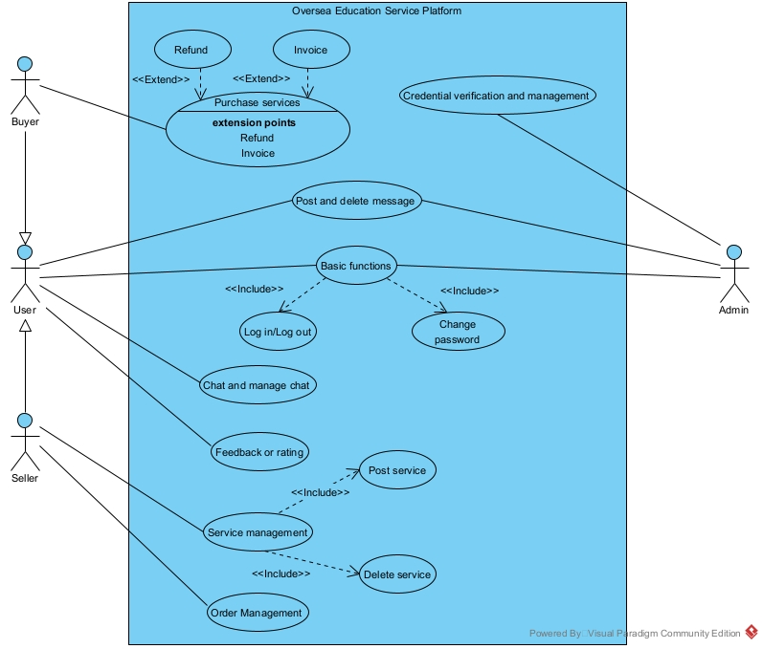

Figure 2: Use case diagram of the Oversea Education Service Webpage

To make trading in this e-commerce web page effectively and make the defined function feasible, all the data should be fetched and stored in a trust-worthy database. Thus, in this project, the database is planned to be architected by MySQL. Here follows the design principles.

There are totally six tables in this database, say, Admin, User, Service, Order, Post Message and Chat. For ‘***Admin***’, they have the highest authority for the database. For example, they could delete any records in the table ‘Post Message’, and they can modify the status attribute ‘is_seller’ in the table ‘User’. For ‘***User***’, it maintains basic information of the user. They have dual identities, seller and buyer, which should be defined by the Admin. However, these two identities should be exclusive (i.e., each user could have one identity only). Other tables are associated with ‘User’ and keep the attribute ‘user_id’ as the foreign key. Therefore, it is possible for indexing records via the SQL instructions like select * from service where user_id =’ab328ahvah’. For ‘***Chat***’, it stores every communication record between different users, which can be accessed by ‘from_user_id’ and ‘to_user_id’. And for ‘***Post Message***’, it retains all the post in the message square, where provides more opportunities for users to find the target service. For ‘***Service***’, it maintains all the services posted by the seller. To be specific, when users apply filter in the webpage to search for their desired services, records in this table will be grouped by the attribute ‘category’. Last, for ‘***Order***’, it tracks every deal between sellers and buyers. In detail, the status will notify the process of the current trading, say, submitted, pending, or completed.

The action and the multiplicity of the database has been specified in the following figure. Thus, this database is designed with indexing efficiency, and certain issues like fan trap and chasm trap has been avoided.

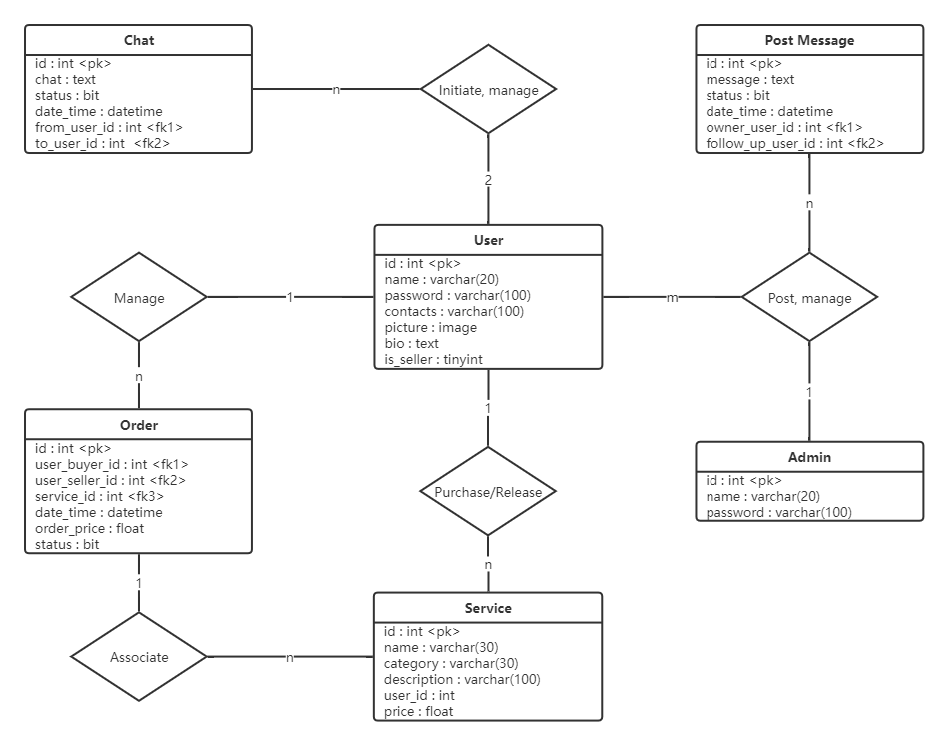

Figure 3: Database entity-relationship diagram

* 1. ***UI/UX Requirements***
     1. ***UI Design***

As shown in Figure 4, there are two roles in this project: seller and buyer. They share some of the pages: Login/Logout, Message, Order, Search and User. Most part of these pages are similar. The buyer has the extra pages for shopping cart. After login, user can press the button under user to switch to the seller mode. Both of seller and buyer can publish a service or request.

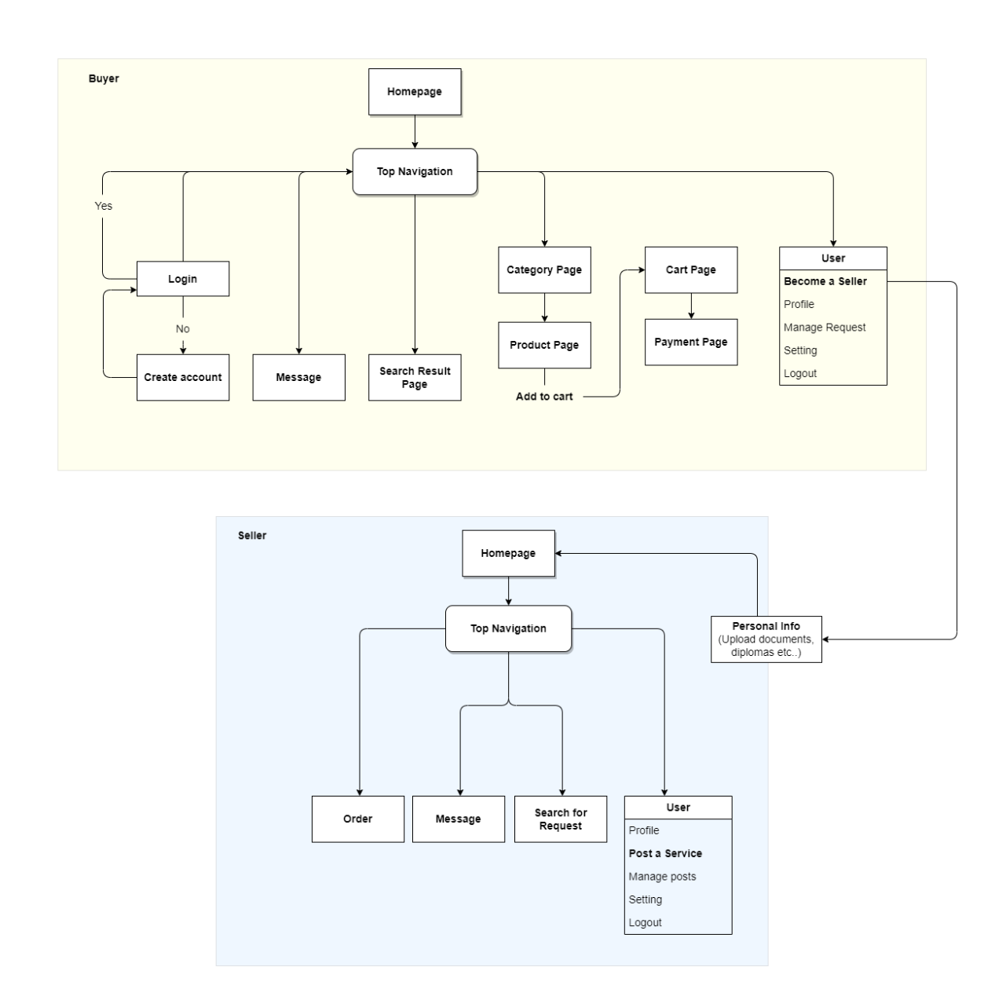

Figure 4: Sitemap of UI Design

* Homepage

Aimed at giving the user a first impression on the content of the ecommerce website. It contains a top navigation bar with a search box and buttons for Messages, Cart, Orders and User. Besides, it displays the slogan and advertising message of the project.



* Sign up and sign in

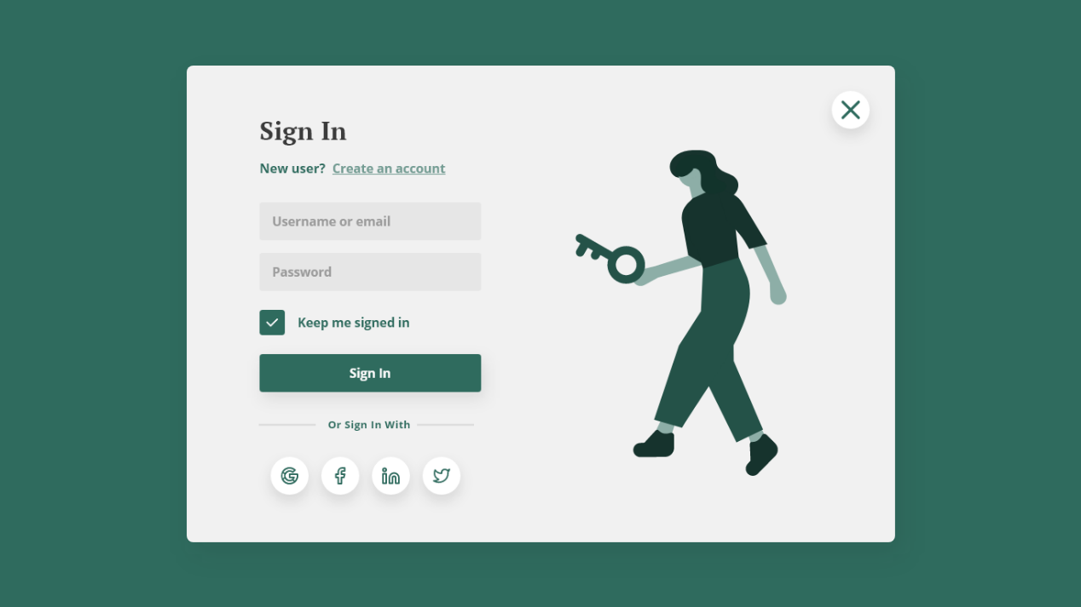

* Search Page

User can search the services or requirements with the search box on top bar at any page. The result of searching can be selected by four types of filters and sort by relevance or time. On each card, user can view the name, rating, price, and introduction of each tutor’s services.



* Orders Page

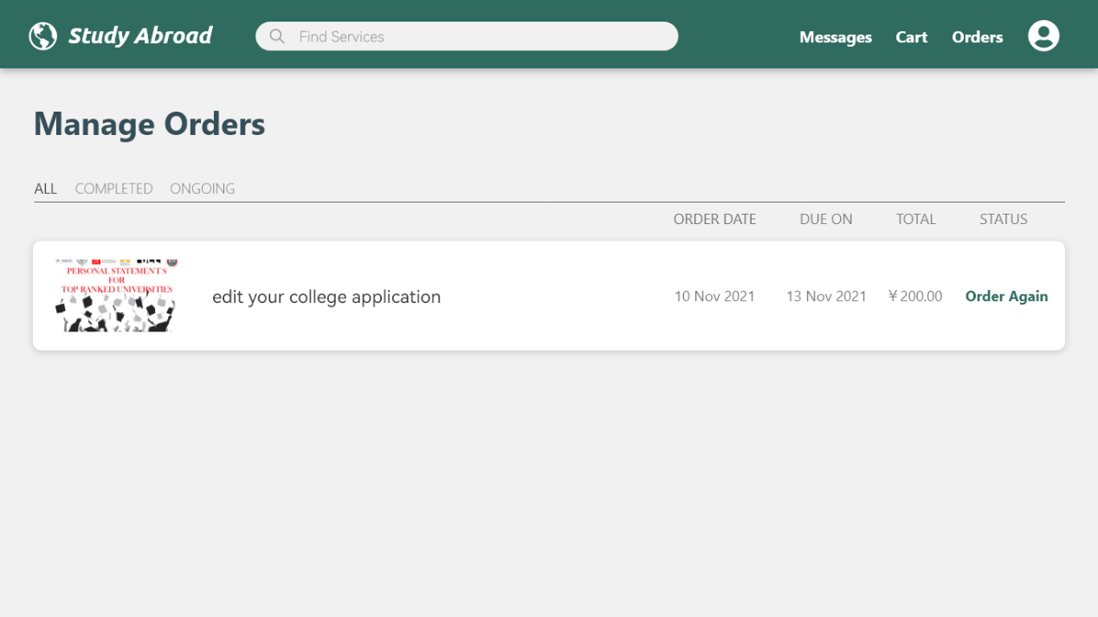

* Messages Page

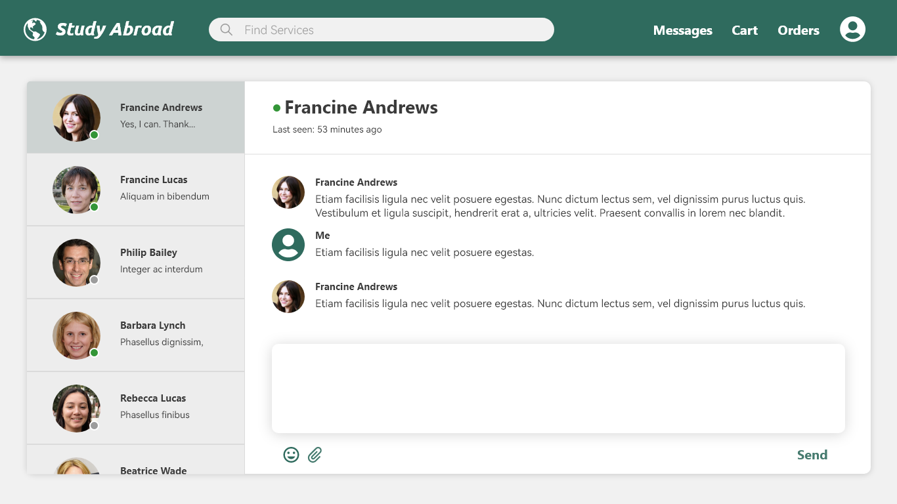

* Cart

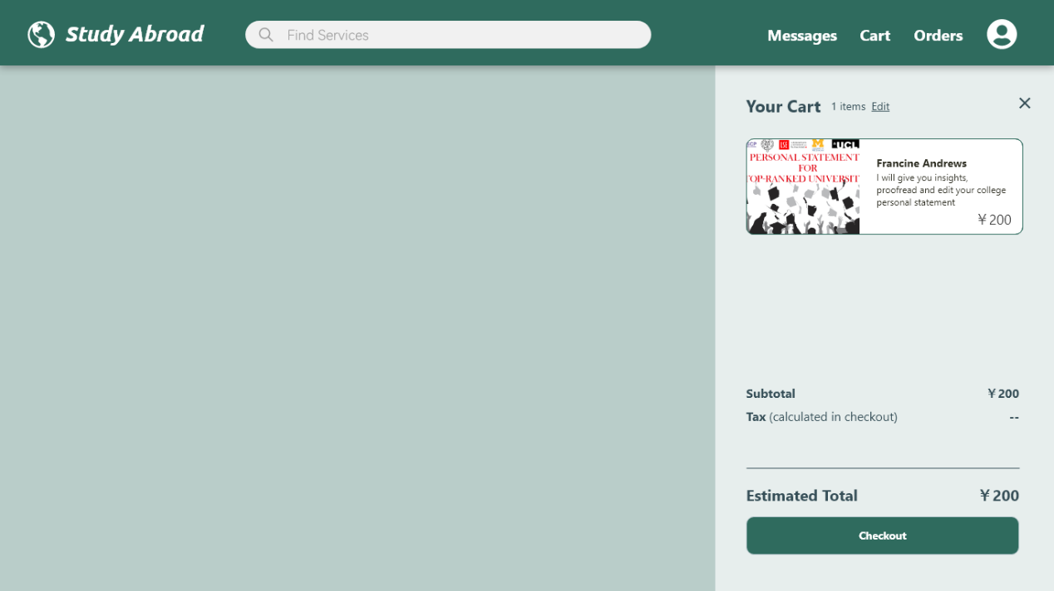

* Product detail

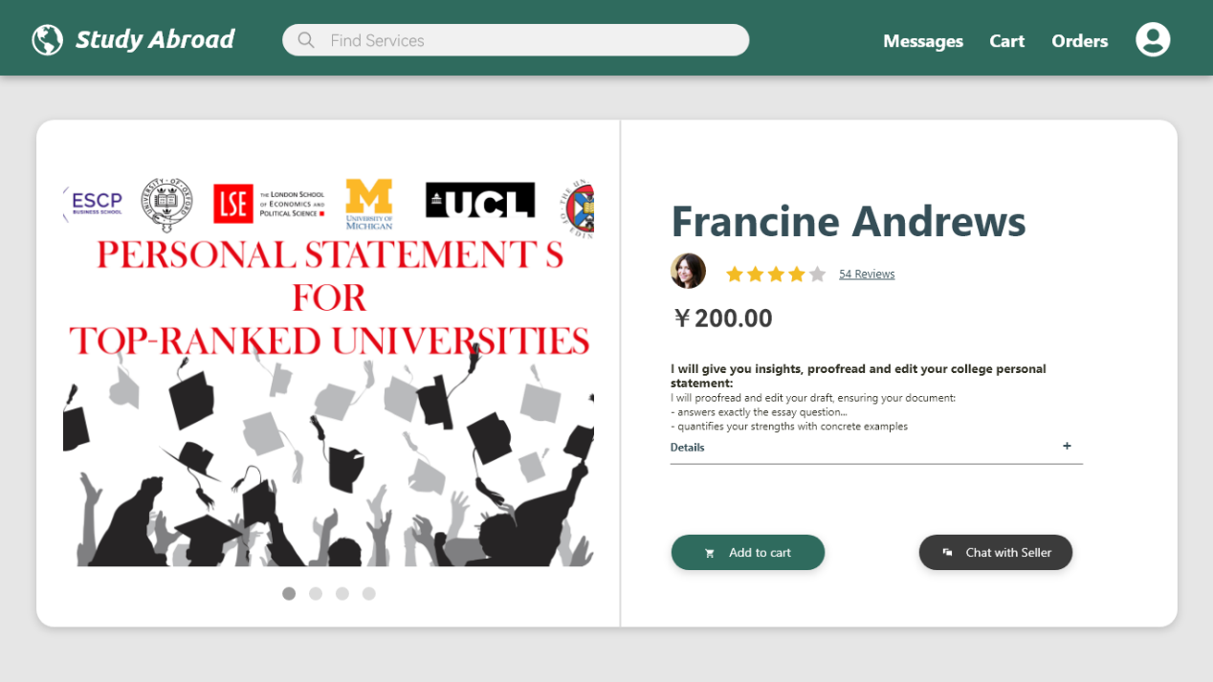

* + 1. ***UX Requirements***
* Meaningful icons are convenient for users to control the interface.
* Top bar is consistent throughout the website. User can go back to the pages they visited or go to the frequently used page through the top bar.
* The interface is well-structured with clear instructions on each page.
* The logic flow between different pages is fluent and similar with other ecommerce websites.

**3. Non-functional Requirements**

* 1. ***Performance Requirements***

1. The startup time of the webpage shall not exceed 5 seconds, and the operation response time in the webpage shall not exceed 3 seconds. In case of network connection timeout, the prompt of connection timeout shall be given and can be reloaded.
2. All Web pages generated by the system shall be fully downloadable in no more than 10 seconds over a 40KBps modem connection.
3. After the user submits the query to the webpage, the time for the query result to appear on the screen shall not exceed 7 seconds.
4. During the normal use time of the webpage, the webpage shall be able to accommodate 500 users at the same time; during peak hours, the webpage can accommodate 1500 users at the same time.
5. The system shall display confirmation messages to users within 4 seconds after the user submits information to the system.

***3.2 Security Requirements***

1. In addition to viewing the product menu and information square, users can only view the product details, chat, search, purchase, and other operations after logging in to the user's account.
2. All network transactions that involve financial information or personally identifiable information shall be encrypted.
3. The webpage shall permit only users who are on the list of authorized Sellers to create or edit products.
4. The system should allow users to view only their previous orders, not those placed by other users.

***3.3 Software Quality Attributes***

Availability-1: The webpage shall ensure that users can get services at any time, and the internal maintenance time of the webpage shall be between 1:00 a.m. and 7:00 a.m. without affecting the normal use of the webpage.

Robustness-1: During the user's payment period, if the user disconnects from the webpage without confirming or canceling the order, the webpage shall enable the user to recover an incomplete order.

Compatibility-1: The webpage shall work properly on multiple major operating systems and webpages, such as iOS, Android, and webpage.

**4. Reference list**

Wang et al (2022) *China Study Abroad Development Report (2020-2021)*. *Center for China & Globalization* [online]. Available at: <http://www.ccg.org.cn/archives/62414> (Accessed: 5 April 2022)

National Bureau of Statistics (2022) *China Study Abroad Services Industry Market Outlook and Future Investment Strategy Analysis Report, 2021-2026*. *ChinaIRN* [online]. Available at: <https://www.chinairn.com/report/20211118/095943257.html?id=1815449&name=wuyanan> (Accessed: 5 April 2022)

Forward Industry Institute (2021) *Understanding the market size, segmentation and growth prospects of the study abroad services industry in China to 2021*. *Forward Industry Institute* [online]. Available at: <https://bg.qianzhan.com/trends/detail/506/210831-293aa02b.html> (Accessed: 6 April 2022).

Ipsos in China (2020) *Study Abroad Trends Report*. *Ipsos* [online] Available at: https://www.ipsos.com/zh-cn/yipusuoipsos-2020haiwailiuxuequshibaogao (Accessed: 7 April 2022).

Yin, K (2014) *State of the Study Abroad Agency Industry Analysis*. *China Education Association for International Exchange* [online]. Available at: <http://www.ceaie.edu.cn/wenxianziliao/xingyezixun/1144.html> (Accessed: 7 April 2022).